Adverbs of Frequency

🔹 What Are Adverbs of Frequency?
# Source: AI Source: Provided by: [Data Path: Persons Table -> ID Column: 1, Name_En Column: Motasem Essam] -> From: [Chatgpt (GPT-4-turbo)] on [7/27/2025]
Adverbs of frequency tell us how often an action happens.
They describe repetition or regularity and answer the question: 👉 "How often?"

✅ Common Adverbs of Frequency
# Source: AI Source: Provided by: [Data Path: Persons Table -> ID Column: 1, Name_En Column: Motasem Essam] -> From: [Chatgpt (GPT-4-turbo)] on [7/27/2025]
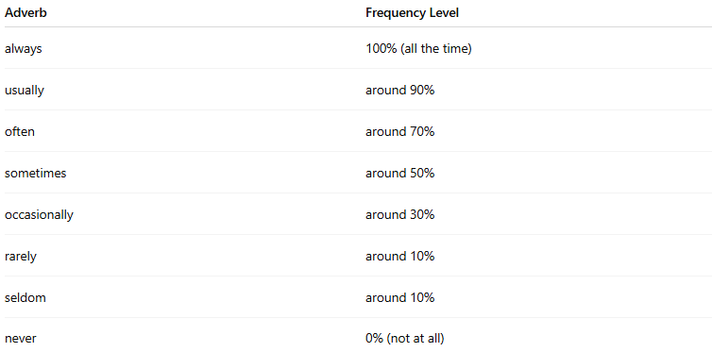
Adverb | Frequency Level
always | 100% (all the time)
usually | around 90%
often | around 70%
sometimes | around 50%
occasionally | around 30%
rarely | around 10%
seldom | around 10%
never | 0% (not at all)

📚 Examples in Sentences
# Source: AI Source: Provided by: [Data Path: Persons Table -> ID Column: 1, Name_En Column: Motasem Essam] -> From: [Chatgpt (GPT-4-turbo)] on [7/27/2025]
- I always wake up early.
- She usually eats breakfast at 7 a.m.
- They sometimes go to the beach.
- He rarely watches TV.
- We never smoke.

🧠 Key Notes
# Source: AI Source: Provided by: [Data Path: Persons Table -> ID Column: 1, Name_En Column: Motasem Essam] -> From: [Chatgpt (GPT-4-turbo)] on [7/27/2025]
- They usually go before the main verb:
✅ He always arrives on time.
- But they go after the verb "to be":
✅ She is usually happy.
- Can also go at the beginning or end for emphasis:
✅ Sometimes I skip lunch.
✅ I skip lunch sometimes.

